2:WEB API HANDS-ON ASSIGNMENT
ASP.NET Core Web API with Swagger

Objective
To create an ASP.NET Core Web API using C#, implement GET, POST, PUT and DELETE methods, configure Swagger, and execute/test the API endpoints.

ValuesController.cs
using Microsoft.AspNetCore.Mvc;
namespace FirstWebApi.Controllers
{
[ApiController]
[Route("api/[controller]")]
public class ValuesController : ControllerBase
{
[HttpGet]
public IActionResult Get()
{
string[] values = { "value1", "value2" };
return Ok(values);
}
[HttpGet("{id}")]
public IActionResult Get(int id)
{
return Ok($"Value with ID = {id}");
}
[HttpPost]
public IActionResult Post([FromBody] string value)
{
return Ok($"Added: {value}");
}
[HttpPut("{id}")]
public IActionResult Put(int id, [FromBody] string value)
{
return Ok($"Updated ID {id} with {value}");
}
[HttpDelete("{id}")]
public IActionResult Delete(int id)
{
return Ok($"Deleted ID = {id}");
}
}
}

Program.cs
var builder = WebApplication.CreateBuilder(args);
// Add services
builder.Services.AddControllers();
// Add Swagger
builder.Services.AddEndpointsApiExplorer();
builder.Services.AddSwaggerGen();
var app = builder.Build();
// Enable Swagger
if (app.Environment.IsDevelopment())
{
app.UseSwagger();
app.UseSwaggerUI(c =>
{
c.SwaggerEndpoint("/swagger/v1/swagger.json", "Swagger Demo");
});
}
app.UseHttpsRedirection();
app.UseAuthorization();
app.MapControllers();
app.Run();

Execution and Output
The project was built and executed successfully. Swagger UI was used to test all required API methods. The screenshots below show the implementation and outputs.
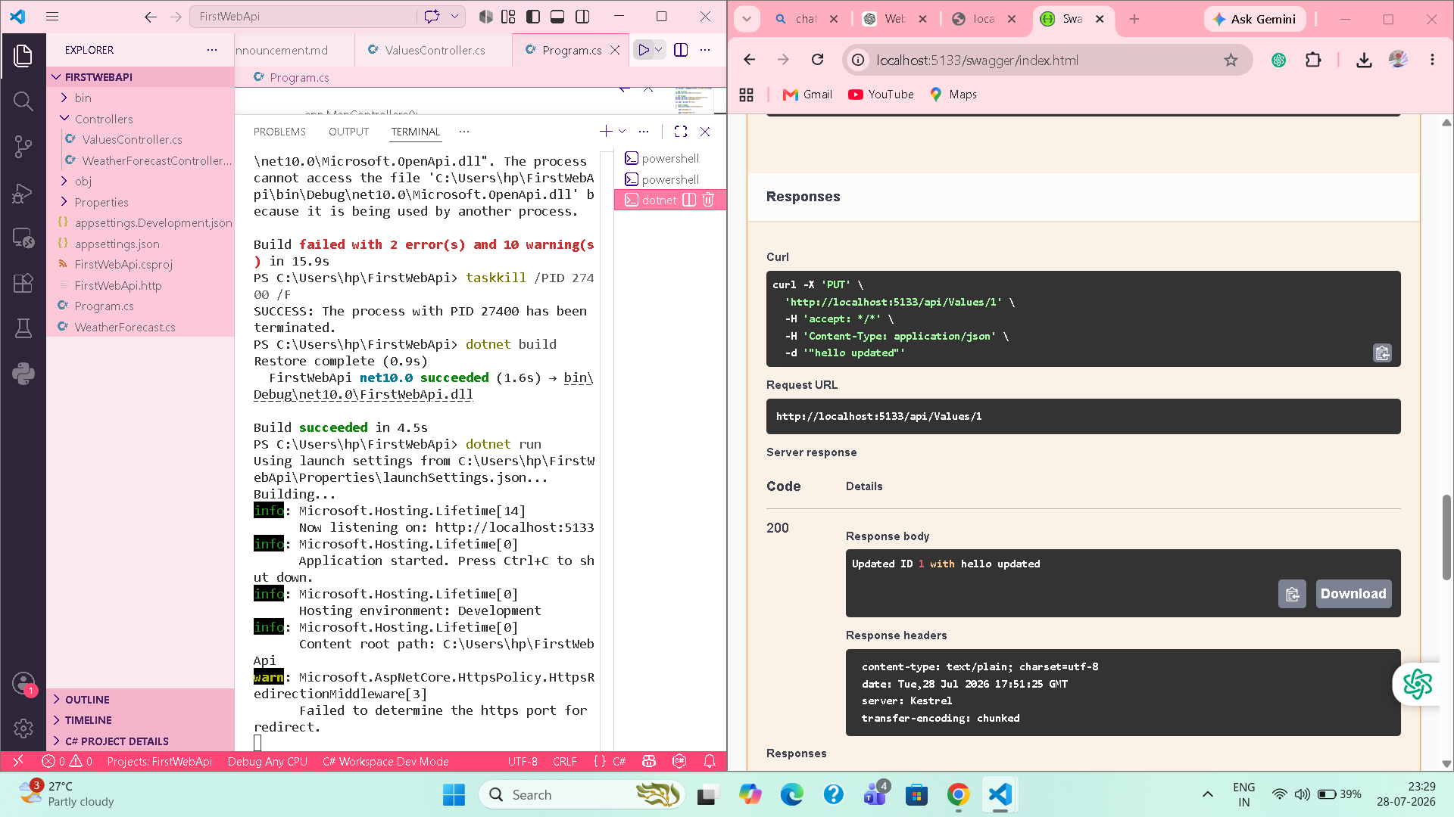
Figure 1: Project running successfully and Swagger opened.
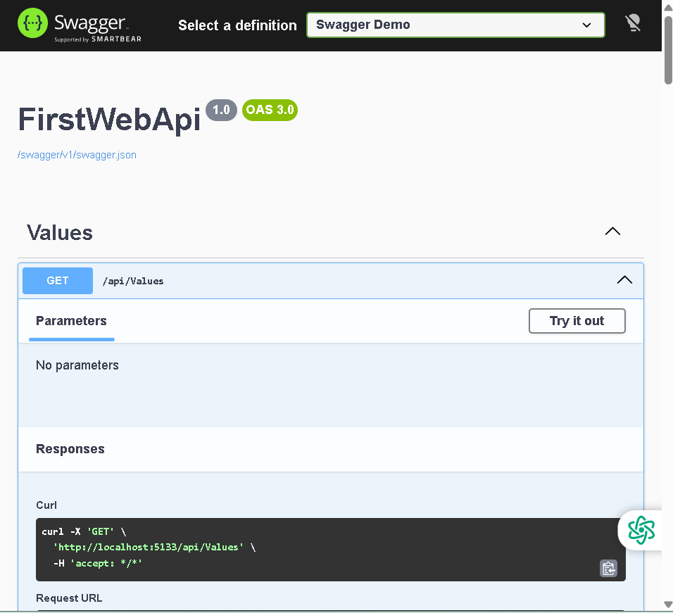
Figure 2: GET /api/Values endpoint in Swagger.
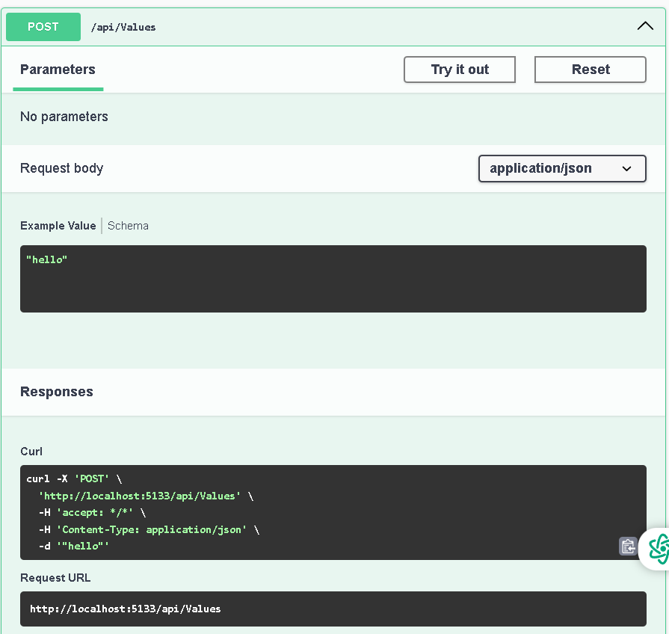
Figure 3: POST /api/Values request.
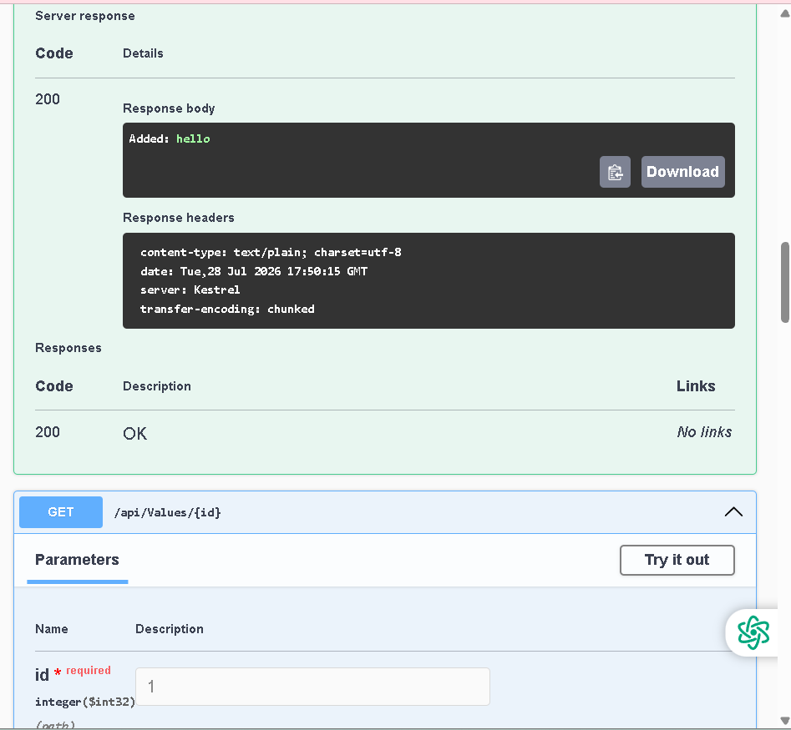
Figure 4: POST response: 200 OK — Added: hello.
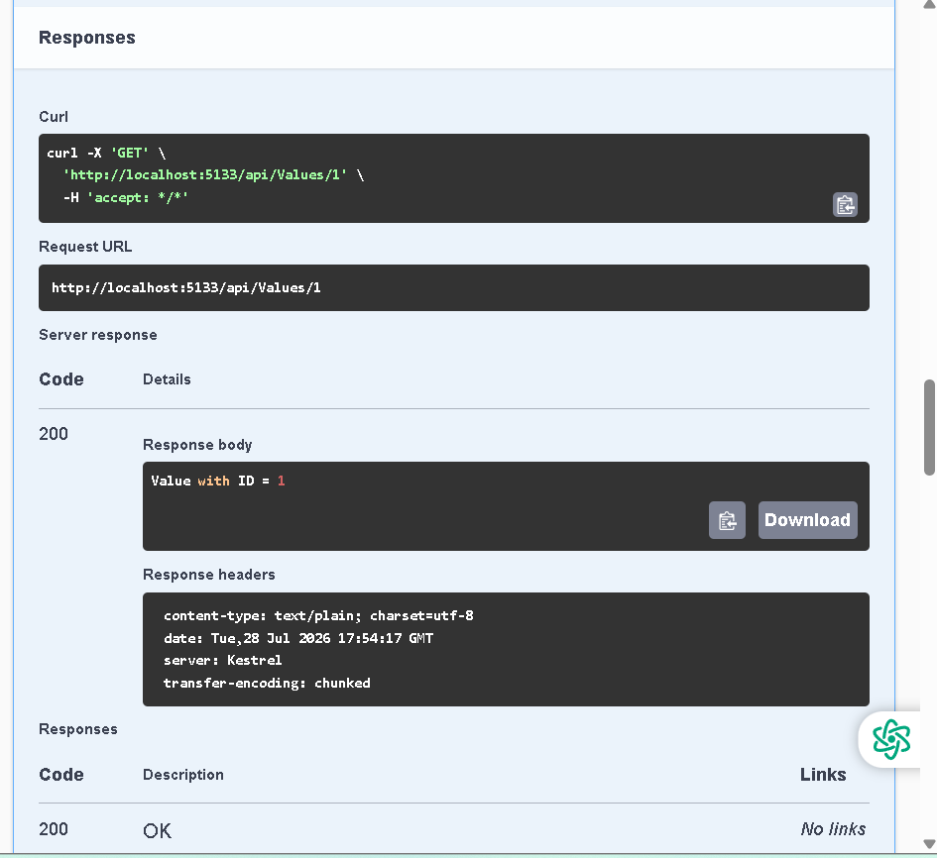
Figure 5: GET /api/Values/1 response: 200 OK — Value with ID = 1.
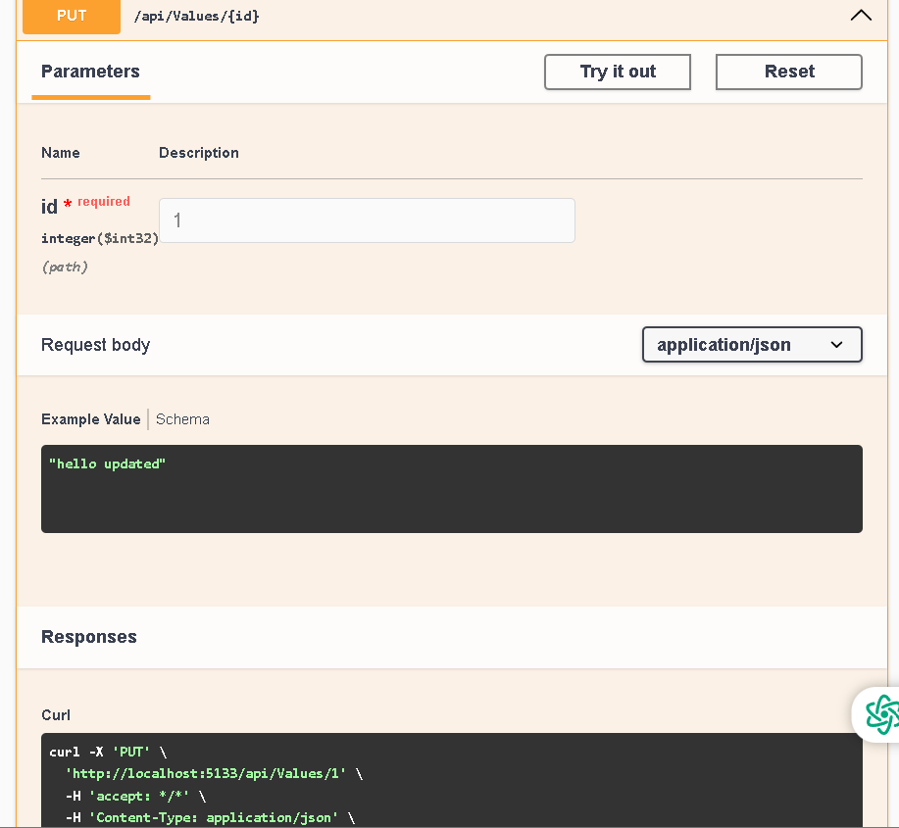
Figure 6: PUT /api/Values/1 request.
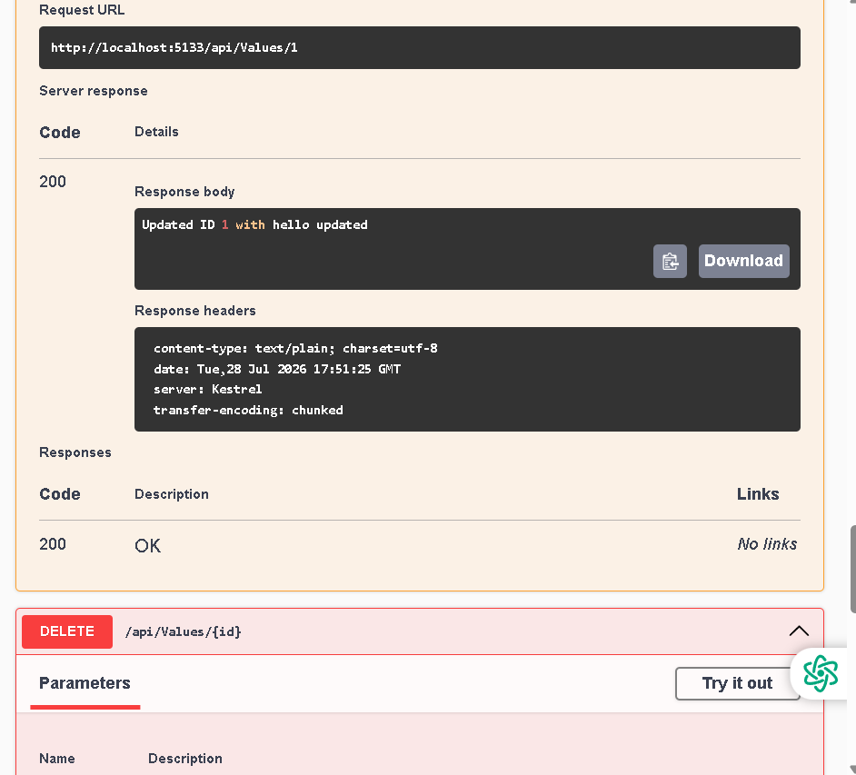
Figure 7: PUT response: 200 OK — Updated ID 1 with hello updated.
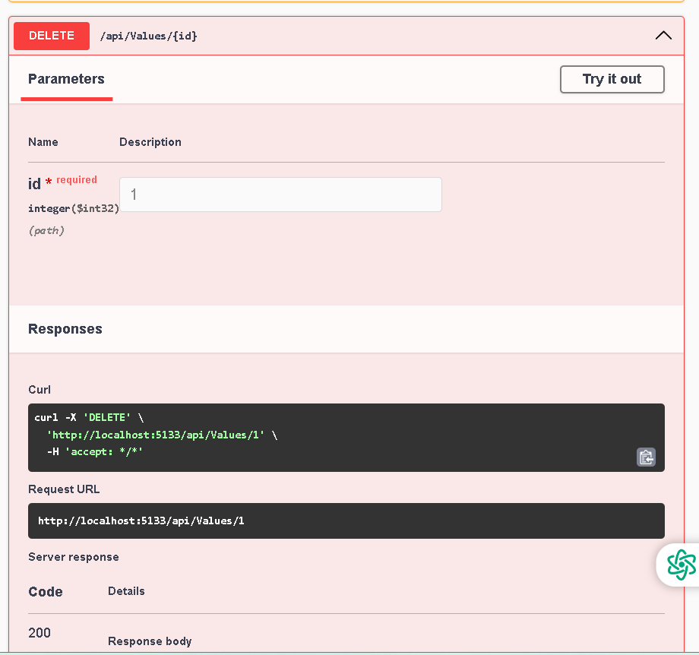
Figure 8: DELETE /api/Values/1 request.
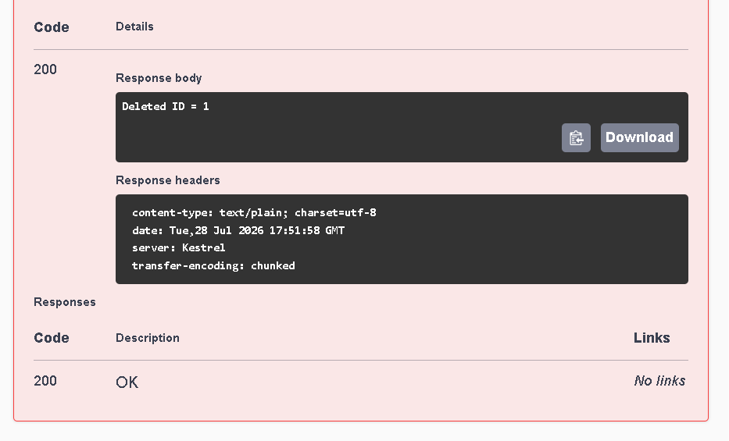
Figure 9: DELETE response: 200 OK — Deleted ID = 1.

Result
The ASP.NET Core Web API was implemented successfully. GET, GET by ID, POST, PUT and DELETE operations were tested through Swagger and returned HTTP 200 responses.

